The original dataset contains 4 tables:

**1. Projects Table**

* ProjectID
* ProjectName
* Category
* Region
* StartDate
* EndDate
* Budget

**2. Expenditures Table**

* ExpenseID
* ProjectID
* ExpenseDate
* ExpenseCategory
* Amount

**3. Impacts Table**

* ImpactID
* ProjectID
* Year
* ImpactMetric
* Value

**4. Stakeholders Table**

* StakeholderID
* ProjectID
* StakeholderType
* SatisfactionRating
* Feedback

Data Modeling Steps:

* **Created Fact Tables:**

Fact_Expenditures (from Expenditures table)

Fact_Impacts (from Impact table)

Fact_Stakeholders (from Stakeholders table)

* **Created Dimension Tables:**

Dim_Projects (from Projects table)

Dim_ExpenseCategory (new - normalized from Expenditures)

Dim_ImpactsMetric (new - normalized from Impact)

Dim_StakeholdersType (new - normalized from Stakeholders)

* **Created Calender Dimension Table:**

Used Calender() function to generate all dates from min StartDate to max EndDate to help in time analysis.

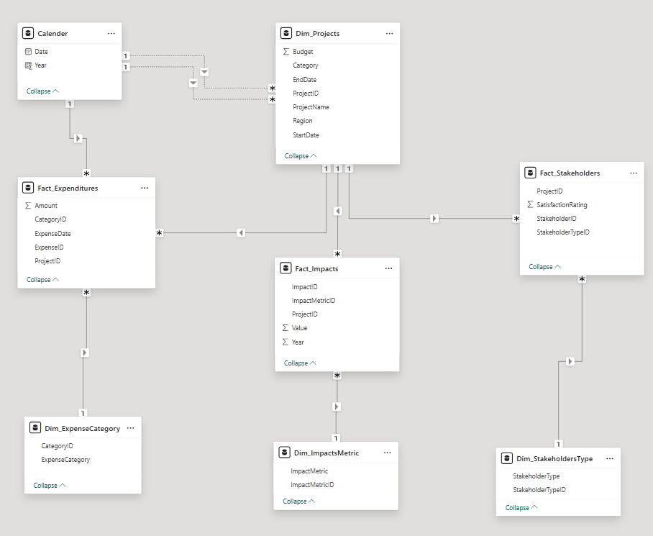

Key Measures:

* No. of Active Projects.
* Average Project Duration in Days.
* Average Satisfaction rate.
* Budget Utilization = Total Expenses / Total Budget.
* Impact Per Dollar = Total Impact Value / Total Amount.
* Projects Within Budget = Projects that have expenses > budget divided total budget.
* Satisfied Stakeholders Percentage = Stakeholders that have rating > 3.
* Total Budget per Category.
* Stakeholder type distribution.
* Utilization and Impact per region.